STAKEHOLDER MAPPING GRID

WHY THIS TOOL MATTERS?
This mapping is an essential tool in the development of a cultural mediation project, as well as in its monitoring.
It provides a clear picture of the various stakeholders involved in the project and identifies their different influences and commitments to the project.
Based on this map, it is easier to establish a relevant action plan, understand how to interact with each stakeholder, and monitor the project's evolution to make adjustments to actions throughout the project.

HOW TO USE IT?

- Identify all the potential stakeholders.
- Analyse their Influence and Interest.
- Create a Matrix and define an action plan.
- Some examples of templates available on the Internet.

TIPS
- Conduct a deep brainstorming to be sure not to forget stakeholders.
- Search locally.
- Use simple words and visuals for accessibility.
- Try digital tools, for example:
Stakeholders Mapping Templates

Stakeholder mapping grid guidelines

1 - Identify all potential stakeholders
The first step is to brainstorm and list all the individuals, groups, or organisations that could be affected by, or could have an impact on, your cultural mediation project. Think broadly:

- Internal stakeholders: the project team, other young participants, supervisors, etc.
- External stakeholders:
  - Cultural institutions: museums, theatres, libraries, cultural centres.
  - Local authorities: town halls, youth services, cultural services.
  - Civil society organisations: neighbourhood associations, NGOs, social centres.
  - Businesses: benefactors, sponsors, local companies.
  - Media: local newspapers, radio stations, blogs.
  - Target audiences: schools, youth groups, local residents.
  - Others: parents, volunteers, experts, etc.

2 - Analyse their influence and interest
Once the list has been drawn up, you must assess each stakeholder's level of influence and interest in relation to your project.

- Influence: How much power does this stakeholder have to positively or negatively influence the project? Can they provide resources (financial, human, logistical) or, on the contrary, create obstacles? Rate them as low or high.
- Interest: How motivated is this stakeholder to get involved in or be affected by the project? Are they very concerned about the objectives and results? Rate this as low or high.

3 - Matrix and action plan
The influence/interest of stakeholders
This is the key tool. Create a simple double-entry table with four quadrants, or use the template below. Place each stakeholder in the appropriate category.

 | High interest | Low interest
High influence | Key partners | To be kept informed
 | Strategy: Manage closely. Involve them heavily in decision-making. They are your essential allies. | Strategy: Keep them regularly informed. Demonstrate the value and usefulness of the project to them. Do not ask them to perform tasks, but ensure their support.
Low influence | To involve | Limited effort
 | Strategy: Encourage their participation in activities. Include them in non-decision-making roles (e.g. volunteers, participants). They are your most engaged audience. | Strategy: Minimal, basic communication. Inform them of the major milestones. Do not expend too much energy on them unless they show increasing interest.

Action plan
For each category, determine specific actions:

- For key partners:
  - Maintain frequent and regular contact as much as possible (phone calls, email, online meetings).
  - Consult them on decision-making.
  - Assign them clear responsibilities.
  - Example: the council that is funding the project.
- For those to keep informed:
  - Send newsletters or informational emails.
  - Present the project at public events.
  - Example: a large industrial group in the city that does not yet have any connection to culture.
- For those to involve:
  - Invite them to workshops and mediation events.
  - Give them an ambassador role.
  - Example: a neighbourhood youth association.
- For limited effort:
  - Include them in the general mailing list.
  - Do not contact them individually, except in cases of specific need.
  - Example: a small association that is geographically distant from the project.

4 - Some interesting templates
Many models are available online, like these.

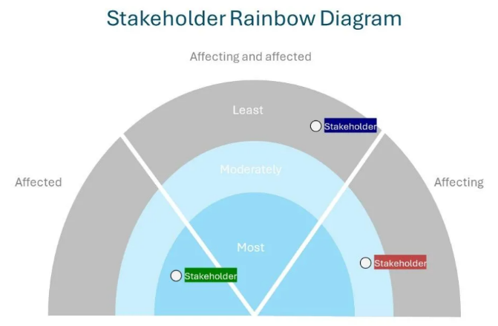
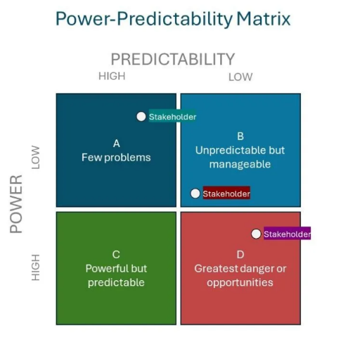
Figure 2 / simplystakeholders.com
Figure 1 / simplystakeholders.com

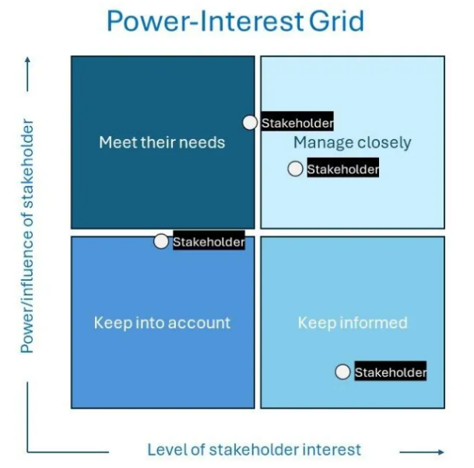
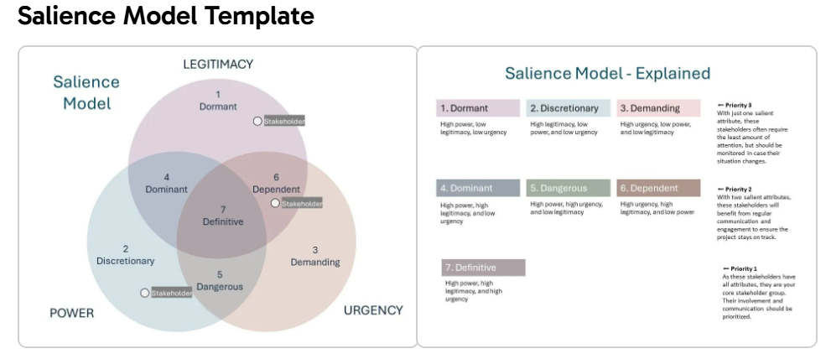
Figure 4 / simplystakeholders.com
Figure 3 / simplystakeholders.com

