SWOT ANALYSIS
(STRENGTHS, WEAKNESSES, OPPORTUNITIES, THREATS)

WHY THIS TOOL MATTERS?
A SWOT analysis is a simple yet powerful strategic tool that helps you understand a situation, project, idea, or organisation from four perspectives: Strengths, Weaknesses, Opportunities, and Threats. By breaking down both internal factors (strengths and weaknesses) and external factors (opportunities and threats), you gain a clearer picture of where you currently stand and what direction you should take. This tool matters because it supports smarter decision-making, helps identify realistic goals, and encourages critical thinking skills, especially valuable for young university students preparing for academic projects, career planning, or entrepreneurship.

HOW TO USE IT?
How to Use It (Step-by-Step)
- Define the topic
Decide what you are analysing: yourself, a project, a student organisation, a business idea, etc.
- List internal factors
  - Strengths: What do you/your project do well? What resources or advantages do you have?
  - Weaknesses: What needs improvement? What limitations or gaps exist?
- Analyse external factors
  - Opportunities: What external trends, chances or possibilities can you use to your advantage?
  - Threats: What risks or external challenges could harm your success?
- Prioritise
Identify the most important items in each category-those that will have the biggest impact.
- Make decisions
Use the insights to create strategies, set goals, or adjust your plans.
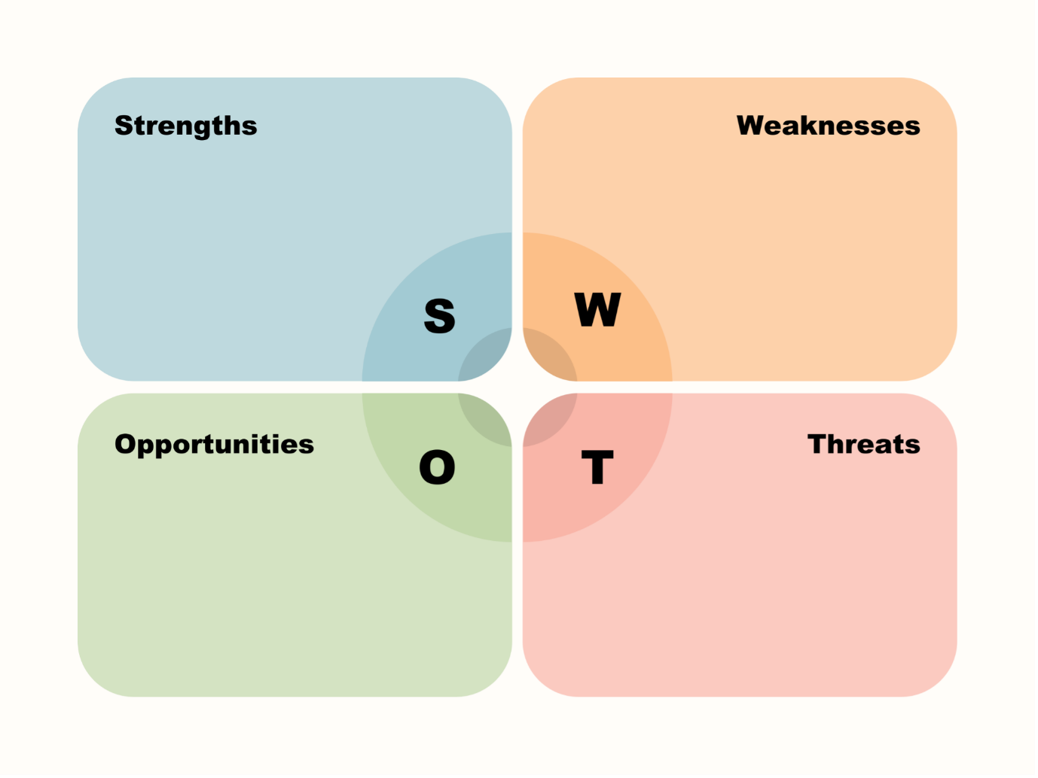

TIPS
Use simple words and visuals for accessibility.
Editable Template (Table)
You can copy/paste this into a document, Miro board, or Google Docs to fill in during a workshop or brainstorming activity.

Strengths (Internal, positive) | Weaknesses (Internal, negative)
• What do we do well? | • What needs improvement?
• What unique resources do we have? | • What skills/resources are missing?
• What advantages do we hold? | • What challenges do we face internally?

Opportunities (External, positive) | Threats (External, negative)
• What trends can we benefit from? | • What external factors may harm us?
• What new possibilities exist? | • What competition or risks exist?
• Where can we grow or expand? | • What barriers or threats are emerging?

